MAGNET T SERIES USER GUIDE

1. Product Image

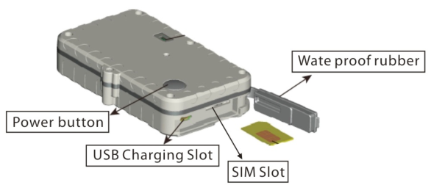
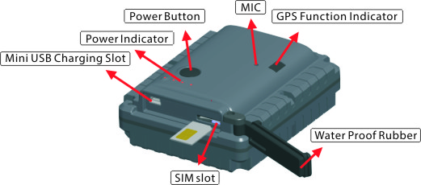

a. T12SE b. T4400SE /T8800SE/T15400SE

Content of the packaging
- Tracking device
- USB Charging cable
c. User Guide

2. Installation Manual
2.1 SIM Card Pre-installation, specification note
a. GSM Normal SIM Only
b. SIM card should have its GPRS function enabled.
d. SMS request will function only if Caller ID function is enabled.

2.2 SIM Card Installations and Removal
a. Open waterproof rubber
b. Insert SIM card into the SIM slot, metal face up, clipped corner to the right.
c. Green light flashes once and turns to steadily on for 10 seconds, and then turns off.
d. Call the device SIM number and it is supposed to get through without answer. (if you are using a data SIM which is not supporting call function, skip this step.)
e. Ensure the waterproof rubber is closed after SIM installation

2.3 Device Installations
a. Avoid all metal environment to make sure device is able to receive GSM and GPS signal.
b. Avoid high temperature environment like above the car engine

3. Button Operation

We strongly recommend you to charge the product before using it the first time. And device will be automatically on once SIM is inserted. Please DO NOT PRESS ANY BUTTON when you use it for the first time.
3.1 Button Operation for GPS function
NOTE: “button” presses must be at 1 second each in all uses

a. Power On: Press control button 5 times. Green light flashes once and turns to steadily on for 10 seconds, and then turns off.
b. Power Off: Send command *poweroff* when SIM card is inserted. The blue indicating light will flash for 5 times
c. Reset: Press control button 15 times to reset all settings. The blue indicating light will flash for 3 times. Insert the SIM again and system will be on.
d. Charge: A red light is steadily on during charging and turns off when it is fully charged

3.2 Panic Button
Press and hold the control button for 5 seconds will trigger a SOS alert to registered master number and will be uploaded to the server.

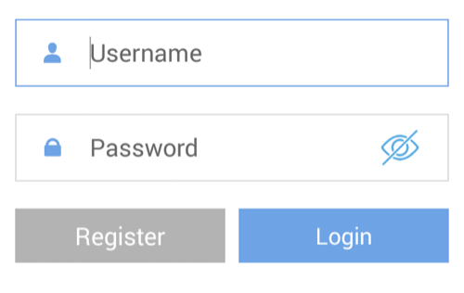
App User Guide

1. Tracking via website and applications

Tracking Website: www.miitown.com
QR Codes of IOS and Android app are at the bottom of the front page, please scan and download.

Username: Registered Master phone number.
Password: Default as 123456.

2.1 Register an Account

2.1.1 Set APN

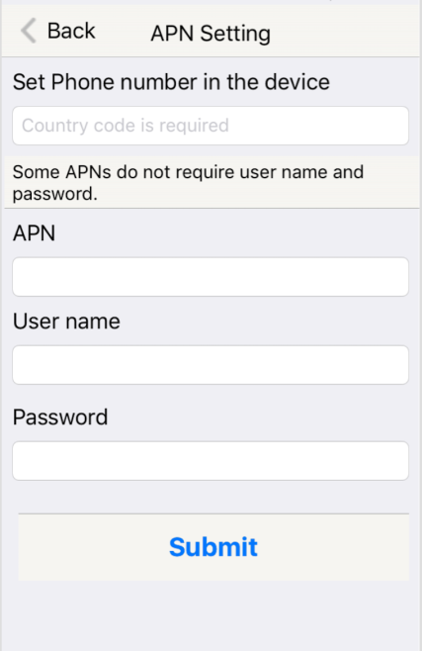
APN is Access Point Name. The correct APN must be set to enable the device to send data to the server. Different SIM has different APN, make sure you have confirmed the correct APN information with the SIM provider when you purchase the SIM

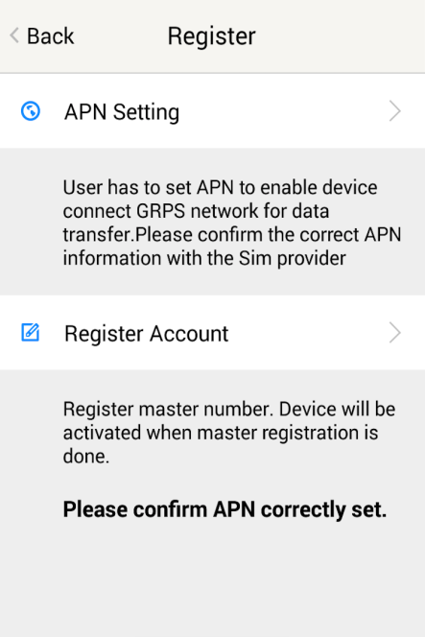

Table underneath is sample of the popular operator data. Please consult the website of your operator to find the APN settings of your SIM.

Operator | APN | Username | Password
KPN (NL) | internet | - | -
Orange (PL) | internet | internet | internet
T-Mobile (US) | internet2.vociestream.com | - | -
Vodafone (NZ) | www.vodafone.net.nz | - | -
O2 (DE) | internet | - | -
TIM (IT) | inbox.tim.it | - | -
Mobister (BE) | web.pro.be | mobistar | mobistar
AirTel (IN) | airtelgprs.com | - | -
Orange（FR) | orange.fr | orange | orange

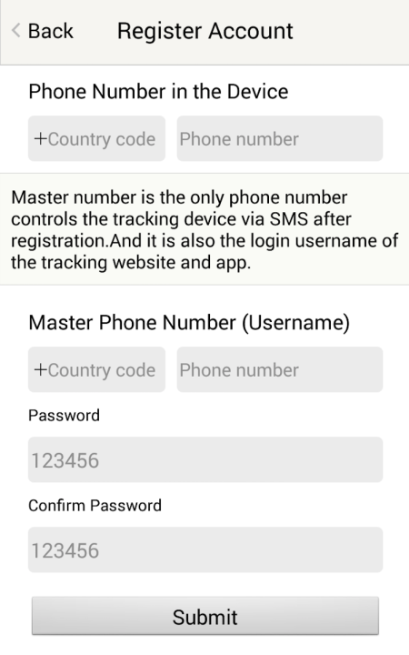
2.1.2 Registering Account

Make sure you put the land code before your phone number and you let out the first 0 of your number.

e.g.: +31612345676 for NL an +32475123456 for Belgium

123456 is the default login password. And it can be changed on the tracking website at www.miitown.com

3. Control Room

Home
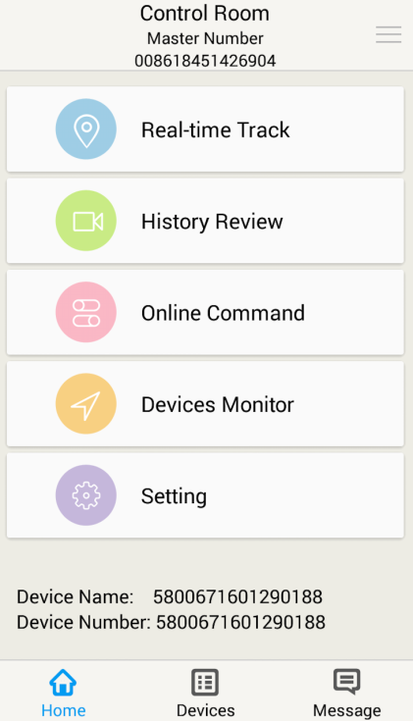
Function list of the app

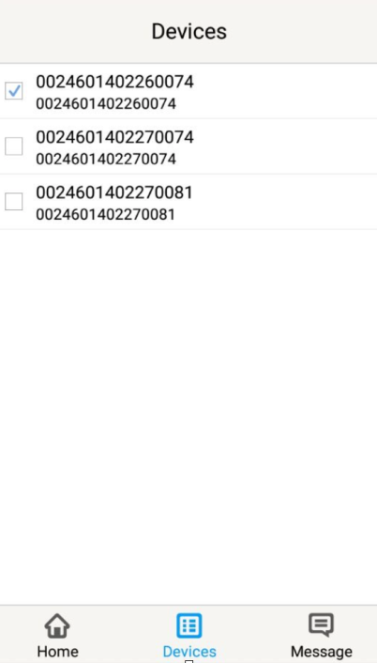

Devices
Show all number devices under the same account. Tap the device’s serial number to select the one you need to control.

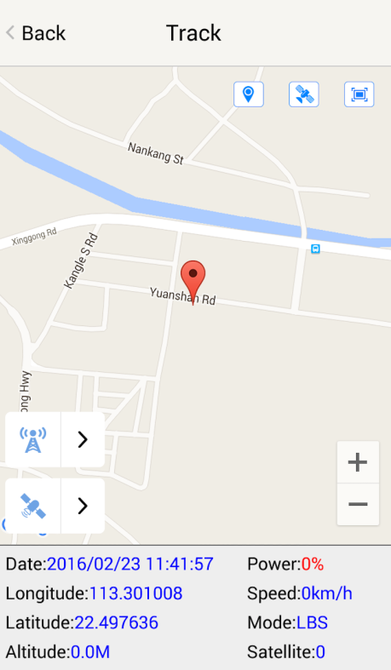

3.1 Real-time Tracking
To get latest location of the device.

Tap to get GSM location

Tap to get GPS location

3.2 History Review
To view the previous location record of the selected device.
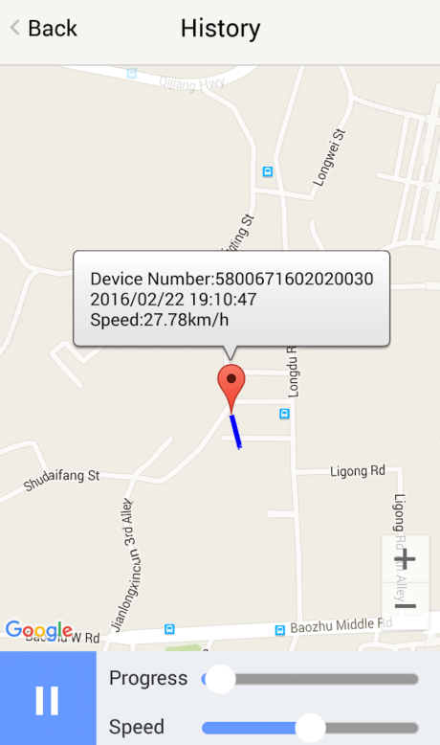

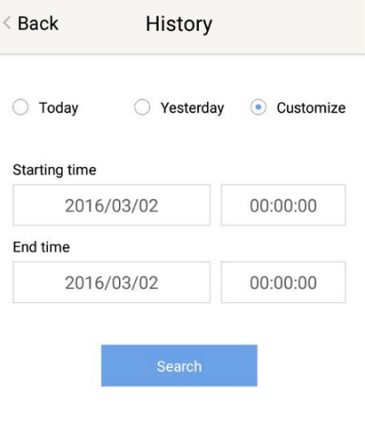

3.3 Online Command
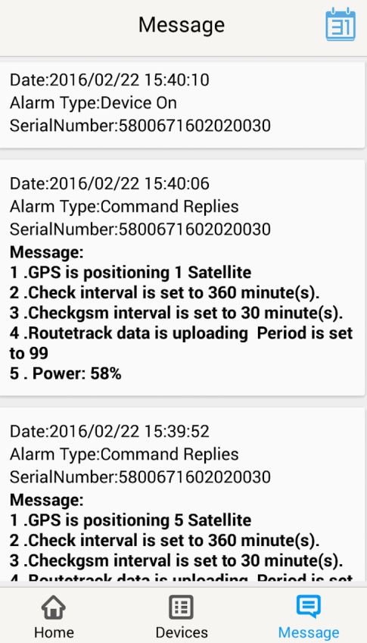
Online Command can control device from APP via SMS, so SMS cost will be charged by the SIM provider of your smartphone, when you send these commands. And all replies from the device will be sent back to app via GPRS data, so replies will be shown as push notification, and all records can be checked in the message section.
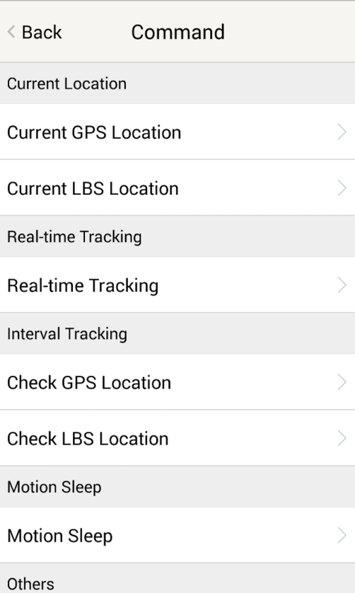

3.3.1 Current GPS Location
To update the latest GPS location of the device. The latest location will be uploaded to website and app map.

3.3.2 Current LBS Location
To update the latest GSM location of the device. The latest location will be uploaded to website and app map.

3.3.3 Real-time Tracking
Enables device to upload 6 locations to server every minute when device is in motion.

3.3.4 Check GPS Location
Device will upload GPS location in appointed interval. No matter device is in motion or not. Default as 1GPS location uploads every 72 hours.

3.3.5 Check LBS Location
Device will upload GSM location in appointed interval. No matter device is in motion or not. Default as 1GSM location every 30 minutes.
Check LBS function is the best power saving tracking function, but distance inaccuracy could up to 1KM

3.3.6 Deep Sleep
Device will go to deep sleep mode and wake up after appointed interval, and will be stay awake for 12 minutes. If there is no new commands received in 12 minutes, device will go back to deep sleep mode for the next set interval.
The phone function will be off during deep sleep, and no call or SMS can be replied until device wakes up.

3.3.7 Motion Sleep
Device will go to deep sleep mode and wake up when motion is detected, and will be stay awake for 12 minutes.. If there is no new commands received in 12 minutes, device will go back to deep sleep mode until the next motion is detected.
The phone function will be off during deep sleep, and no call or SMS can be replied until device wakes up.

3.3.8 Others
3.3.8.1 Status Query
Check system status, replies will be shown in the message section

3.3.8.2 Device Information
Check software edition information and device’s serial number. Replies will be shown in the message section.

3.4 Device Monitor
All devices will be shown in the latest location.

Note:
- Interface of the App you download could be different from the screenshot in the user manual since it is kept updated.
- Certain functions in the App might not support the model you purchase. Please check the following SMS Command Operating Guide to confirm detail functions list of your tracker.

SMS Commands Operating Guide

SMS commands are for non-smartphone user, or who would like to control the device through SMS commands only, without using the App.
Please make sure the SIM card you insert in the device support sending SMS function, otherwise you won’t be able to receive any command reply

1. Registration

1.1 Set APN

APN is Access Point Name. The correct APN must be set to enable the device to connect network and send data to the server. Different SIMs have different APN, make sure you have confirmed the correct APN information with the SIM provider when you purchase the SIM.

Command
*apn* APN’s name*username* password*
Some APN goes without username and password, you can just leave them blank.
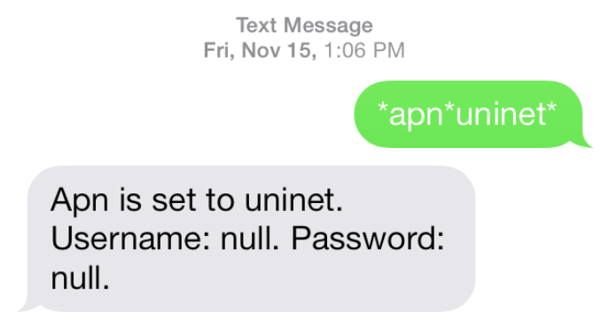

Example: Orange France
APN: orange.fr
Username: orange
Password: orange
Correct command format *apn*orange.fr* orange*orange*
Example: China Union
APN : uninet
Username: null
Password: null
Correct command format *apn*uninet*

Your cell phone will receive confirmation saying that the appointed APN is set (See screenshot).

1.2 Registering the “Master” Controller

Use cellphone to send SMS *master*123456*+country code plus your cellphone number*to the device SIM number. 123456 is the default password, it can be changed by changing password command as showed on 1.3.
Example
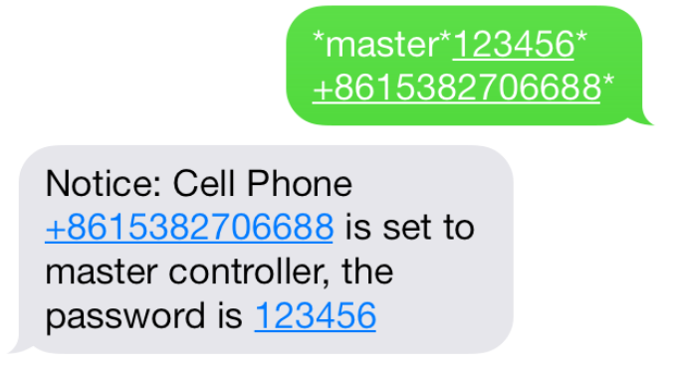
*master*123456*+319876543210* (+31 refers to Netherlands country code, 9876543210 refers to the cell phone number)

Once your cellphone receives the confirmation sms, it will become the only master phone to the tracker (See screenshot).

NOTE: The device will ONLY listen and respond commands from this number unless you choose to turn on the multi controller function and open the device to any cell phone number.

1.3 Changing the Password
SMS: *password*654321* (654321 refers to new password)

Changing password command has to be sent only from the master number. And new password has to be applied to when you need to register the device with a new master number.

2. Motion Alert
The motion alert enables device triggered a call/sms alert when motion is detected, after 3-minutes of non-movement.

2.1 Set vibration sensitivity
There are 5 levels of the motion sensitivity. 1 being the most sensitive, 5 the least, default setting is 1.
SMS: *sensitive*1-5*

2.2 Set SMS/CALL Alert
There will be a Call/SMS alert sent to master number when any motion is detected, after 3 minutes of non-movement. The system default setting is call alert, and can be turned off by command.

SMS: *alertoff*
To turn off motion alert function.
SMS: *smsalert*
To enable motion sms alert function.
SMS: *callalert*
To enable motion call alert function.

3. Tracking via SMS

3.1 SMS: *locateaddress*
Master number will receive the GPS address of the device via SMS. If GPS location is invalid, device will reply the closest cell tower location instead.

3.2 SMS: *locatemap*
Master number will receive a Google map link. Click the link to view the map via cellphone browser. If GPS location is invalid, device will reply the closest cell tower location instead.
And this function is suitable for smart phone user only.

4. Tracking via website and applications

Tracking Website: www.miitown.com

ID: Registered Master phone number.
Password: Default as 123456.
It can be changed on the tracking website.

Recommended Web browsers are Chrome, Firefox or cell phone default browser.

4.1 Real-time Tracking (High Power Consumption)

Routetrack function enables device to upload 6 locations to server every minute when device is in motion.

4.1.1 Routetrack
SMS: *routetrack*1-99*
1-98 represents the number of hours that the routerack function works. 99 represents to turn the routetrack function always on.
Example
*routetrack*1* means uploading 6 location GPS data every minutes for 1 hour

4.1.1.1 Rsampling
Rsampling is to set routetrack data collecting interval.
The smaller interval, the higher accuracy, but the higher power consumption.
SMS *rsampling*1-999*
1-999 represents seconds of data collecting interval, default as 10 seconds

4.1.1.2 Rupload
Rupload is to set routetrack data upload interval.
The smaller interval, the higher accuracy, but the higher power consumption.
SMS *rupload*60-999*
60-999 represents seconds of data uploading interval, default as 60 seconds, minimum rate should not be less than 60

Example
*rsampling*30* plus *rupload*120* means 4 location data will be uploaded to server every 2 minutes when routetrack function is on.

SMS:*routetrackoff*
To turn off route track function.

4.2 Check GPS Location (Medium Power Consumption)

Check function enables device to upload GPS location in an appointed interval, no mater device is in motion or not in motion. If GPS location is invalid, system will upload the closest cell tower location instead.

SMS: *checkm*5-9999*
5-9999 represents the number of minutes that the device Check’s data upload interval, minimum rate should not be less than 5.
Example
*checkm*360* means uploading GPS data every 6 hours.

Note:
1. Check function is able to work with routetrack and Checkgsm functions at the same time.
2. System is default as *checkm*4320*. 1 location will be uploaded to server every 72 hours.
3. Location will be uploaded to server when device is in motion or not in motion.

4.3 Check GSM Location (Low Power Consumption)

Checkgsm function enables device to upload ONLY the GSM location in appointed interval of time. Data will be uploaded to server on both occasions, no matter device is in motion or not in motion.
And this function can be used with routetrack and Check function at the same time.

SMS: *checkgsm*5-1800*
5-1800 represents the the number of minutes of Checkgsm’s data upload interval, default as off; rate should not be less than 5.
Example
*checkgsm*30* means uploading GSM data every 30 minutes.

4.4 Track Off

Track off will end all the tracking functions, including routetrack, checkm, checkgsm, timing locate and period locate.

SMS：*trackoff*

5 Upload Alert
The upload alert function enables device upload alert status to the server including motion alert, low battery alert etc. User can check alert status on the tracking website or message section in app.

This function is default as ON.

SMS：*uploadalert*on*
To enabled upload alert function.
SMS：*uploadalert*off*
To disable upload alert function.

6. Sleep Function (Lowest Power Consumption)

6.1 Interval Sleep
Device will go to deep sleep mode and wake up after appointed interval, and stay awake for 12 mintues. If there is no new commands received in 12 minutes, device will go back to deep sleep mode for the next set interval.

Note: System will shut down GPS and GSM module during deep sleep period, so no call or SMS can be received or responded.

SMS：*sleep*1-99*
1-99 refers to the hours of appointed sleep interval.
Example
*sleep*6* means to enable device to go to deep sleep mode and wake up in every 6 hours.

6.2 Motion Sleep

Motion Sleep function enables device to stay in deep sleep mode and wakes up once motion is detected. System will upload the current location of the device. If motion continues, system will stay on and operate the previous tracking settings. If there is no further motion detected, device will go back to deep sleep in 12 minutes. And the circle repeats.

Note: System will shut down GPS and GSM module during deep sleep period, so no call or SMS can be received or responded.

SMS: *sleepv*
To enable motion sleep function.

SMS: * sleepoff*
To turn off motion sleep and interval sleep function.

7. Status query

SMS: *status*

To check device setting status and performance. GPS ranking data will shows up only when routetrack function is on.

8. Low battery Alert
Low battery alert function suitable for models with backup battery only. Please check your models number in Hardware Specification to confirm.

There will be a low battery SMS alert sent to master number when battery drops to 20% of it’s capacity, and the routetrack function will be turned off for power saving. And it will resume working when battery is charged. The alert number can be appointed to any other cellphone number if needed.

Appoint low battery alert number

SMS:*lowbat*alert cellphone number*

Note: Please make sure country code is included in the cellphone number.

Example
*lowbat*+319876543210*

9. SOS Alert

SOS Alert function enables device to send SOS alert to preset number when the panic button is triggered.
Up to 3 SOS numbers can be preset.
The registered master number is the default SOS alert number.

9.1 Register the SOS alert number

SMS: *master*123456*cellphone number 1*cellphone number 2*cellphone number 3*

NOTE: Please make sure country code is included in the cellphone number.

9.2 Panic Button

Power button is the panic button. If there is a SIM card inserted, press and hold the button for 5 seconds to trigger SOS alert. Preset numbers will receive the following SOS SMS

“SOS! HELP! SOS!! HELP!! SOS!!! HELP!!!” System default as off.

SMS: *soson*
To enable SOS alert function.

SMS: *sosoff*

To turn off SOS alert function.

10. Reboot

SMS: 88888888

Reboot system, previous settings will not be cleared.

11. Master query

SMS: 999999

To check registered master number, password and device’s serial number.

12. Default

SMS: default

To operate factory default, previous settings will be cleared.

13. Multi Controller

Allows any cellphone number to check the device location and status besides the master number.

13. 1 SMS: *multiquery*

To enable multi controller function.

13. 2 SMS: *multiqueryoff*

To turn off the multi controller function.

14. Device Information

SMS:*about*

To check device information including software edition and serial number.

Command Setting List

Function | Command | Description
APN Settings | *apn*APN’s name  *username*password* | Enable device to access internet.
Master Setting | *master*123456*country code (plus) cellphone number* | Register master number.
Password Changing | *password*654321* | Original password is default as 123456. 654321 refers to new password.
Vibration Sensitivity | *sensitive*1-5* | Set motion alert sensitivity, 1 is the most sensitive, 5 is the least
Motion Alert | *alertoff* | End motion alert
 | *smsalert* | Motion alert via SMS
 | *callalert* | Motion alert via Call
Address Query | *locateaddress* | Address information of current location.
Google Map Search | *locatemap* | Google Map link with current location.
Real-time Tracking | *routetrack*1-99* | Device will upload 6 locations every minute.1-98 represents routetrack data upload interval in hours. 99 represents always on.
Real-time Tracking sampling interval | *rsampling*1-999* | 1-999 represents seconds of routetrack sampling interval
Real-time Tracking upload interval | *rupload*60-999* | 60-999 represents seconds of routetrack upload interval
Real-time Tracking Off | *routetrackoff* | End routetrack function.
Check Location | *checkm*5-9999* | 5-9999 represents minutes of check function  data upload interval
 | *checkoff* | End check function
 | *checkgsm*5-1800* | 5-1800 represents minutes of check gsm function  data upload interval
Track Off | *trackoff* | End all the tracking functions.
Upload Alert | *uploadalert*on* | Enable upload alert function
 | *uploadalert*off* | End upload alert function
Interval Sleep | * sleep*1-99* | 1-99 represents device wake up interval in hours.
Motion Sleep | * sleepv* | Motion Sleep function with motion alert.
Sleep Off | *sleepoff* | End Interval sleep and motion sleep function.
Status query | *status* | Check system status.
Multi Controller | *multiquery* | Enable multi controller function.
 | *multiqueryoff* | End multi controller function.
SOS Alert | *soson* | Enable SOS alert function.
 | *sosoff* | Disable SOS alert function.
Device Information | *about* | Software edition information and device’s serial number.
Reboot | 88888888 | Reboot the system, previous settings will NOT be cleared.
Master Query | 999999 | Registered master number information, password and device’s serial number.
Low Battery Alert Number | *lowbat*country code (plus) cellphone number* | To set low battery alert number.
Factory Default | default | Default system, previous settings will be cleared.
Power off | *poweroff* | Power off the device

Hardware Specification
Model | Size | Back up Battery
T12SE | 102mmx63mmx21mm | 2600mAh
T4400SE | 108mmx56mmx40mm | 5200mAh
T8800SE | 110mmx88mmx40mm | 10400mAh
T15400SE | 165mmx88mmx42mm | 18200mAh

  - GPRS:MTK 6260D/6261
  - Quad band; GSM 850/900/1800/1900 MHzAntennae: Internal, GPRS Class 12
  - Power: Rechargeable, Lithium-ion Battery
  - Built-in Vibration/motion sensor
  - GPS: U-BLOX G7020-ST, 50 channel
  - Antennae: Internal
  - Position Accuracy: >=5m
  - Sensitivity: Tracking: (R)C161 dB, Cold starts: (R)C148 dB, Hot starts: (R)C156 dB
  - Cold start:<27s, Warm Start: <5s, Hot Start: 1s
  - A-GPS: AssistNow Online and AssistNow Offline services.

